Overview:
This ESG explains how the finance teams can check the status and Tax Codes of the Projects as well as to unblock the WBS elements for financial postings to occur.
There are many different “codes” or status steps that will be seen as part of the set up. Some apply only to the Project Definition and others to the WBS elements. The table below shows which part of the Project you will find the appropriate codes (the bold lines are appropriate for Finance staff the rest for reference):
Code | Meaning | Impact
NTRY | Entry | The Project is being set up and it is still being built
TAXI | Tax Status Incomplete | The Project is set up and needs tax codes added
TAXC | Tax Status Complete | The Project is set up and tax is set up
CHEK | Final Check Complete | The project is checked and ready to be used
REL | Released | The project has been released
BUDG | Budgeted | There is a budget released on the WBS element
AUC | Asset Under Construction | This is an Asset Project that has been released
AVAC | Availability Control Active | Can’t spend more than the released budget
SETC | Settlement rule created | Staff costs will settle to the cost centre
BLK£ | Blocked pre finance tax code entry | Can’t post income or expenditure against the WBS until it has been unblocked by finance
UBLK | Allows finance post tax code entry | The WBS has been unblocked by finance so income and expenditure can be posted
NCHG | No Change WBS number | Can’t make changes to the WBS element number once it has been saved
NTEC | No TECO until project release | Can’t technically complete until project has been released
CLSD | Closed | The WBS Element has been closed and no postings can be made to it
Once the finance routine is complete the operational staff will still need to release the project, without this the WBS elements can not be used.
Procedure for finding Projects needing tax coding:

- Running the WBS element report can be done via the Portal path:
Projects > Project Reports > Reports > Common Tasks > Assigned Code
The following screen will be displayed:
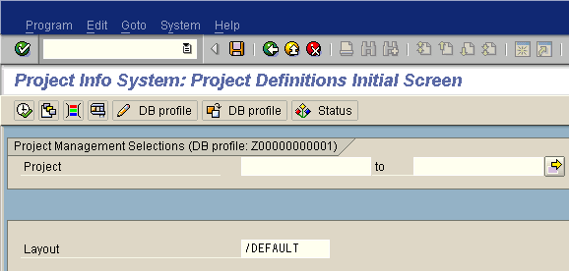
- Click on the icon. The following pop up window will appear:
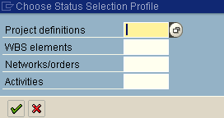
This allows us to look for WBS Elements that are awaiting tax assignment by the hub team.
- In the Project Definitions field click on the search icon .
- From the list of options select ZTAXI : This indicates the projects that have not had the tax code set on them as yet.
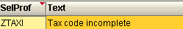
- Click on the green tick icon .
- In this example we will look at all the projects which have the TAXI code for Lithuania. If you run this as a hub then you will need to include all the countries in your region.
Click on the dynamic selection icon.
- From the list of following folders, click on the white arrow in front of Org. units definition.
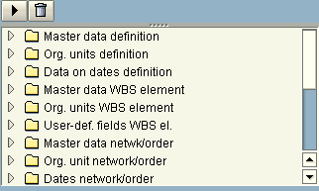
- Double click on the Company Code and the field will move to the right hand side of the screen
- Enter in the Company Codes that you are responsible for setting up. Note that if you are setting up multiple countries you will need to use the yellow arrow to enter multiple selections.
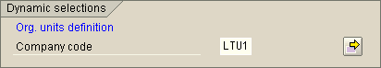
- Click on Execute .

- A list of the all the project definitions for the countries that you selected that do not have the tax set will then appear in a list as shown below.

- Here is a screen shot of the Project Definition from the Project Builder screen confirming that this project has not had the tax added to the list.
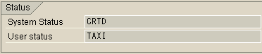

Procedure for Setting Tax and Unblocking WBS Elements for Posting:

- Running Project Builder can be done via the Portal path:
Projects > Project Planning > Definition and Structure > Common Tasks > Project Builder
The following screen will be displayed:
- Click on the open icon.
- In the project definition field enter the project number that you noted down from the first part of this ESG.
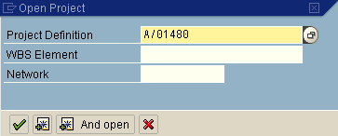

- Click on the green tick icon to continue.

- On the left hand side of the screen you will see the Project Definition of your project highlighted in yellow:
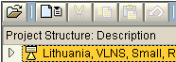
Click on the white arrow next to the Project Definition to expand the structure.
- Click onto the Summary WBS Element that you can now see:
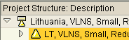
- Over on the right hand side of the screen the details that are now displayed relate to the WBS that you have just highlighted i.e. the summary WBS Element
Scroll down towards the bottom of the screen until you can see the field for Tax Code and enter in the appropriate tax code. This is usually A0.
- Repeat this process for every WBS element that needs to have the tax code added to it by further expanding the WBS structure.
- Now the Status needs to be changed so that operational staff can post to the WBS elements. To change the statue en mass click back on the project definition
- From the menu path at the top of the SAP screen follow:
Edit > Status > User Status > Set & Pass On
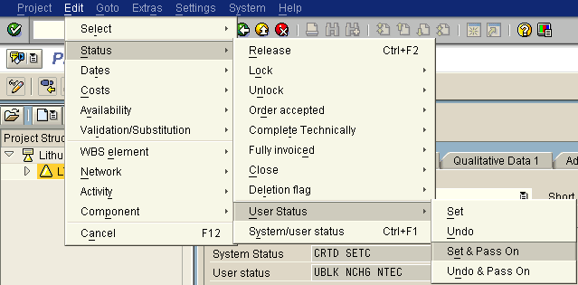
- From the list of options available in the list double click on the UBLK this will ensure that all the WBS elements have been set up correctly.
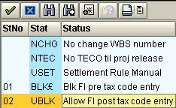
Following this procedure means that you do not have to set the status on each WBS separately.
- A message telling you what the system has and has not set up will then be displayed.
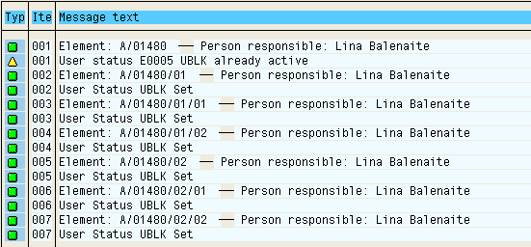
- The project manager can now be informed that the tax and status have been set and can carry on with the rest of the project set up.
Click on the yellow exit icon to return to carry on with FABS.

